IBM Watson require an interface program between the Jeopardy! PCs which works the amusement and the segments. Presentation is not in any way great and befuddled the per users, the creator specifically discussed the diversion and how it is played however he didn't specify what a Watson is, the thing that should be possible with it and how IBM utilizes Watson for calculation. The creator said that Watson can't hear the host's judgment and depends on the score to know whether the answer was right or not but rather he didn't say any motivation behind why Watson is not utilizing discourse acknowledgment or some other administration to perceive the discourse. The primary obligation of this interface is to fathom the clashing occasions and to overhaul the status of the diversion. The amusement has rolled out couple of improvements like classifications which has pictures, recordings or sound information since Watson can't see or listen, it simply had speaker and a screen to demonstrate the status of the diversion however creator missed why they have not enhanced the Watson to see and hear the outside world

The amusement has 3 rounds and in initial 2 rounds, there are 5 classifications and in every class there are 6 pieces of information. Framework sends status of the diversion board to all candidates at whatever point piece of information is chosen through Ethernet without web get to however he didn't say any explanation behind not giving web access to the contender. Is it out of diversion guidelines or some other reason?

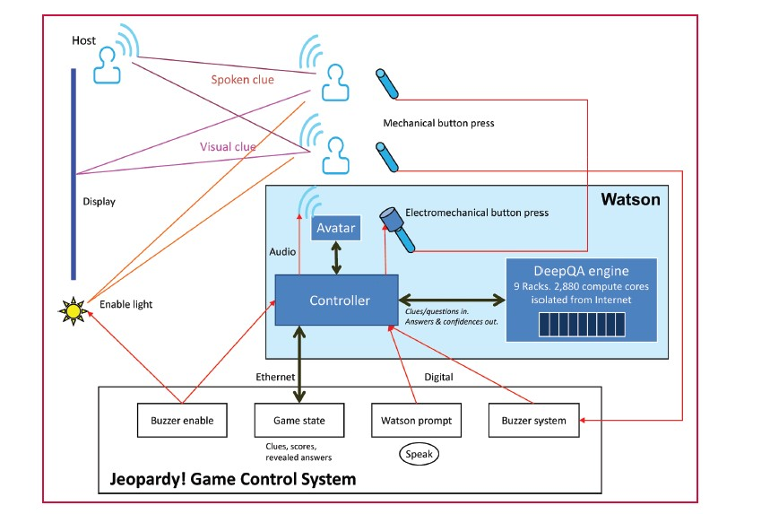

Figure: Communication paths

Watson chooses pieces of information utilizing s system part like every day twofold wagering, last risk! Wagering, choosing whether to endeavor answer or not and couple of more methodologies. In any case, creator has not pointed about the calculations and equipment utilized, its productivity in selecting sign and time taken for calculation of choice of pieces of information. The Watson stands up the yield utilizing TTS (Text-To-Speech) administration of some VIP after numerous hours of recording and preparing. Does recording covers all the words and how it is maintained new words without knowing his voice, how effective it is and voices enhances time to time by utilizing AI or profound learning.

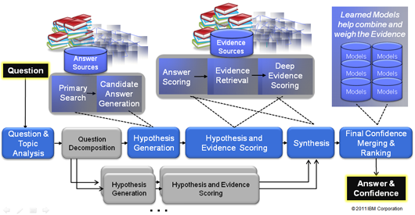

Figure : DeepQ/A engine architecture.

The sign content and its area on the load up is sent to the Watson controller inside the precise time a human reacts the change on the retina. How this exact time is computed and creator haven't demonstrated any functional reports or values as a proof of this time. These intimations are sent to the Watson group which has immense machines for handling profound learning and machine learning calculations which are associated by private web which is not quite the same as the above Ethernet. The creator discussed how messages are sent to QA motor and its engineering, conventions utilized for sending this message. QA motor procedures these signs. Here the creator didn't talk about the calculation or information structures utilized.

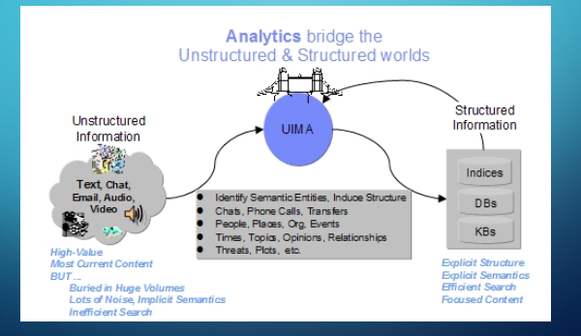

Figure:Unstructured Information Management Architecture.

Subsequent to handling the pieces of information, Watson peruses out utilizing the ringer for flagging. The ringer is actualized utilizing solenoid and C++, java code for programming side. The postponement is relied on upon calculation those programming codes and ways. It is safe to say that they are create any deferrals for flagging? Controller utilizes computerized I/O for checking ringer signals which has rang first. In the event that Watson wins the buzz, administrator sends the sign to Watson. This is the main circumstance where human mediation is requirement for Watson in playing danger amusement. Subsequent to accepting the yield, PC stands up utilizing sound.

Watson's main three answers are shown for every piece of information with their certainty score in a graphical outline however creator has not called attention to whether they are shown to everybody on the screen or it is shown for its inward reason. There is additionally bouncing back alternative if a player gives erroneous answer. Watson will react the re-empowering of ringer flag yet creator specified that there are more risks for committing errors in bouncing back yet it registers once more. Here there is feeling the loss of some clarity. He didn't clarify unmistakably with an illustration.

Author showed couple of details and stage of Watson like processor, RAM, number of centers however didn't specify about the Deep QA machines and bunches in it, adaptations of dialects and instruments utilized. Watsons symbol is only the screen or screen which we are talking from the earliest starting point. This has 30 states which responds taking into account the need and circumstance however didn't revealed each one of those states and when it responds.

References:

* Lewis, Burn L. "In the game: The interface between Watson and Jeopardy! "IBM Journal of Research and Development 56.3.4 (2012): 17-1.
* <http://www.wsj.com/articles/SB10001424052748703439504576116163439390834>
* <https://uima.apache.org/doc-uima-why.html>